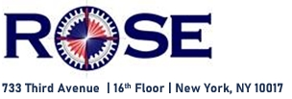

CTPAT Statement of Support
To be displayed at Reception, all warehouse receiving locations and in all departments that handle international transactions, such as Accounting and IT. The company website should also mention this statement.

Our company is a Partner in CTPAT, the U.S. Customs-Trade Partnership Against Terrorism program.
We have voluntarily joined this program to promote safe and secure international traffic between our foreign suppliers and ourselves.

We and our Partners in commerce adhere to CTPAT-mandated MSC (Minimum Security Criteria). Our Partners include the foreign manufacturers of our products, the trucking companies that transport merchandise from the manufacturers to the overseas ports and airports, as well as the consolidators, freight forwarders and carriers that stuff, seal, transport and ship our containers and ULDs to our US destinations.

We and our Partners are committed to protect our Supply Chains from criminal activities such as illegal weapons and drug trafficking, terrorism, human smuggling, contraband, money laundering and cyber intrusions.

Our employees follow, on a daily basis, the MSC that pertain to their Departments and the tasks they perform.

